Hy3 Preview YouTube KOL Briefing

1. Video Requirements
Try out the newly released Hy3 model. Pick any ONE of the evaluation directions — conversation (chat, writing, search, etc.), coding and agents, or instruction-following and in-context learning — and publish a YouTube video. (we provided some sample cases in another Excel file)
We look for in-depth general model reviews, no less than 4 minutes . (Reference case: https://x.com/TencentHunyuan/status/2053771684482851255) Even better if you could develop AI agents based on Hy3.
Please include the test prompts you used along with the model outputs. Your video content should incorporate the latest information about Hy3 and some of the core messaging points, see below the basic information.

2. Review Link
https://openrouter.ai/tencent/hy3-preview
You may log in OpenRouter via Google account, link your credit card to buy tokens. The rate is about 250RMB per 1B tokens as told. You can claim reimbursement by providing transaction screenshots later.

3. Basic Information for Hy3 Preview on April 23
On April 23, Tencent Hunyuan released and open-sourced Hy3 preview — a fast-and-slow-thinking fused MoE language model with 295B total parameters and 21B activated parameters, supporting a maximum context length of 256K. Overall performance reaches the best level among models of the same size, combining strong practical utility with excellent cost-effectiveness.
Hy3 preview is the first model released since Hunyuan rebuilt its pre-training and reinforcement-learning infrastructure in February this year. It is also the most intelligent model Hunyuan has released to date, delivering substantial improvements in complex reasoning, instruction following, in-context learning, chat, code, and agentic capabilities.
In addition, Hy3 preview supports integration with popular open-source agentic products such as OpenClaw, OpenCode, and KiloCode, and is already available on Tencent Cloud's large-model service platform TokenHub.

4.Core Messaging Points

a. Hy3 preview — the first step of Hunyuan's rebuild
The launch of Hy3 preview marks a brand-new starting point for the Hunyuan large-model family.
Since February 2026, Tencent Hunyuan has rebuilt its pre-training and reinforcement-learning infrastructure, and has also rebuilt three guiding principles for practical, utility-oriented models:
• Systematic capability: We don't believe in being a one-trick pony. Even a single application such as a coding agent requires deep coordination across reasoning, long-context, instruction-following, conversation, code, tool use, and more.
• Authentic evaluation: We deliberately move beyond public leaderboards that are easy to game. Instead, we evaluate and improve the model's real-world combat effectiveness through the latest exams, hands-on product testing, self-constructed problem sets, and other means.
• Cost-effectiveness: Practical utility cannot exist without commercial viability. We jointly design the model architecture and inference framework to drastically reduce task cost, making intelligence both affordable and high-quality.
Hy3 preview is precisely the starting point of Hunyuan's rapid exploration into practical large models that solve real-world problems.

b. Hy3 preview delivers across-the-board improvements in chat, code, agents, and math/science reasoning
— Outstanding instruction following and in-context learning
Drawing inspiration from our own business scenarios, Tencent Hunyuan introduced CL-bench and CL-bench-Life as innovative ways to evaluate a model's in-context learning ability, and Hy3 preview shows significant improvements in both in-context learning and instruction following.
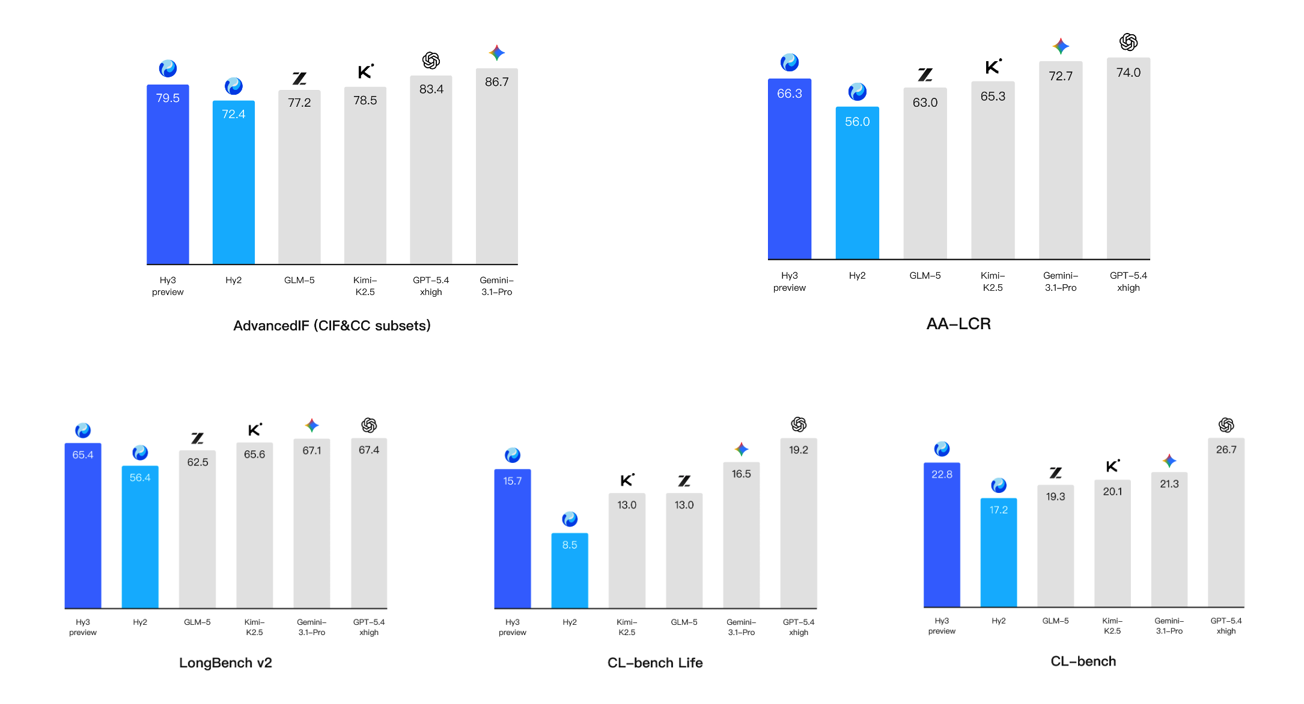
— Strong complex reasoning capability
Complex reasoning is the foundation on which the model solves a wide range of problems. Hy3 preview performs strongly on challenging STEM reasoning benchmarks such as FrontierScience-Olympiad and IMOAnswerBench, demonstrating generalizable strong reasoning ability.
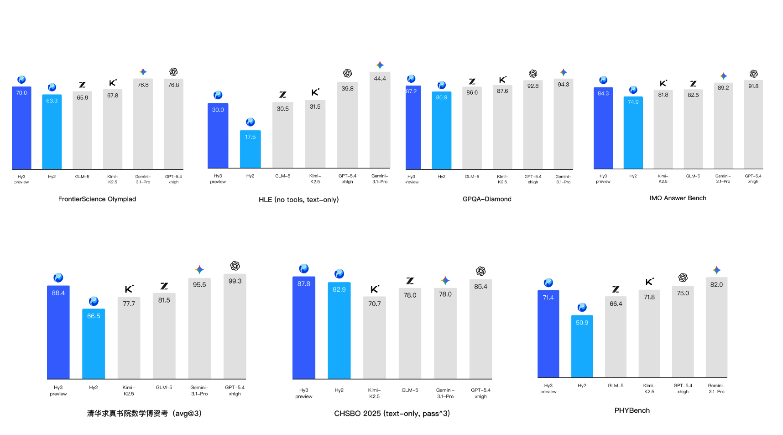
— Code and agentic capabilities show the largest gains, with excellent cost-performance ratio
Code and agents are the areas where Hy3 preview has improved the most. Thanks to the rebuild of the reinforcement-learning framework and the large-scale expansion of RL tasks, the Tencent Hunyuan team has quickly achieved competitive results on mainstream coding-agent benchmarks such as SWE-Bench Verified and Terminal-Bench 2.0, as well as on mainstream search-agent benchmarks including BrowseComp and WideSearch.
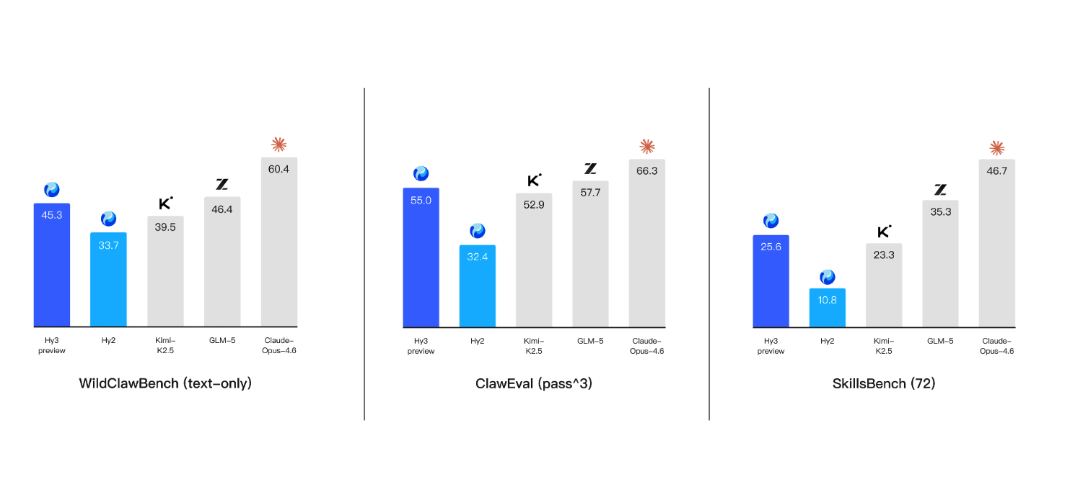
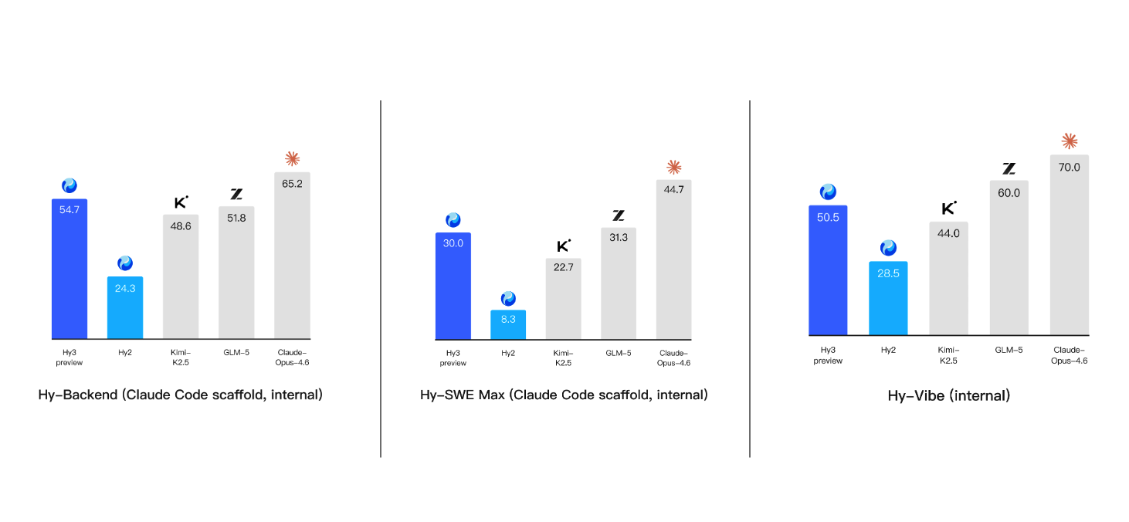

c. Hy3 preview boosts inference efficiency by 40%, achieving the most competitive cost-performance ratio
On Tencent Cloud's large-model service platform TokenHub, Hy3 preview's input price starts as low as RMB 1.2 (equivalent to 0.17 USD) per million tokens, and output price as low as RMB 4 (equivalent to 0.59 USD) per million tokens. In addition, Tencent Cloud and Hunyuan have jointly launched a custom Hy3 preview Token Plan package, with the personal edition priced from as low as RMB 28 (equivalent to 4.1 USD) /month — providing a more cost-effective option for agent development and for building "lobster" applications.
— Headroom on API pricing: at equivalent quality, token prices can reach 50–70% of competitors'.
— Lower deployment barrier: enterprise customers need fewer GPUs.
— Faster response: less compute = lower latency = better user experience.
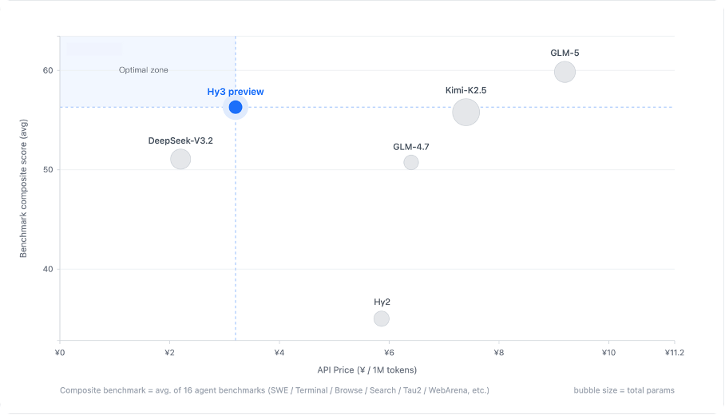

d. Fully integrated into Tencent's core businesses, with clear gains validated across multiple flagship AI products
Prior to its official launch, Hy3 preview was tested in Tencent's major AI businesses — including Yuanbao, CodeBuddy/WorkBuddy, ima, Tencent Docs, Peacekeeper Elite, and more — with notable positive gains.
On the Yuanbao side, Hunyuan and Yuanbao engaged in deep co-design. On one hand, the model was targeted at hard-core metrics such as intent-understanding accuracy, quality of text creation, and deep search; on the other hand, it underwent fine-grained tuning on writing style, prose, emotional intelligence, content organization, and professionalism. This tight model–product coordination delivers a smarter and more "human-like" interactive experience for users.
On CodeBuddy/WorkBuddy, Hy3 preview cut first-token latency by 54%, reduced end-to-end duration by 47%, and lifted success rate to 99.99%+. In real user environments, Hy3 preview has stably driven complex agent workflows of up to 495 steps, covering diverse office scenarios such as document processing, data analysis, knowledge retrieval, and MCP tool-chain orchestration.
In Peacekeeper Elite's AI NPC scenario evaluation, Hy3 preview not only accurately understands character settings in out-of-match persona-playing scenarios but also produces highly relevant, value-adding responses to open-ended questions, delivering a more authentic, natural, and immersive conversation experience. In complex in-match combat scenarios, the model's response latency is at an industry-leading level and its pacing closely matches that of real player chat, demonstrating excellent stability and outstanding human-like role-playing capability — an overall impressive performance.

5. Evaluation Directions
• Everyday conversation (small talk, writing, search, etc.)
• Coding and agents
• Instruction following and in-context learning

The accompanying Excel file provides sample cases; you are welcome to experience the model in combination with your own use cases.

